Enterprise COM Customisation

Source Update Procedures

1st November 2001

Introduction
This document details the procedures to be followed to update the COM Customisation Source following a change to the Type Library.

All paths are specified for Mark’s machine (NEWDELL1) with the MarkD6 login, the following network drive mappings are used:-

X: = SBS_SERVER\VOL2:\ENT500 \

Here is a brief overview of the sections of this document:-

Regenerating Delphi Event Sink Components
The Event Sink component is used by the TEntCustom component to interface the Events published by the COM Customisation object inside Enterprise. It is largely generated automatically using a utility written by Binh Ly.

It should be updated whenever the Interfaces are changed.

Rebuilding the Delphi Component Packages
We supply packages for Delphi 3, 4, 5 and 6 containing a TEntCustom component which gives an extremely simple interface into the COM Customisation. If the TEntCustom component is changed or the Event Sink component it uses is changed then the packages will need to be rebuilt.

Revision History
01/11/01: MarkH - Updated document to reflect the changed directory paths on the new machine (NewDell1), the new version of Binh Ly’s Event sink Implementor (v2.0) and the move to Delphi 6.0 for Enterprise v5.00.

01/11/01: MarkH / Eduardo – The Delphi 3 and Delphi 4 components have been withdraw unless there are demands for them to be supplied, only Delphi 5.01 and Delphi 6.01 components will be generated and supplied with v5.00.

Regenerating Delphi Event Sink Components
The Event Sink components are generated using the Delphi Event Sink Utility by Binh Ly currently installed as d:\Program Files\Borland\BinhLy\EventSinkImp.EXE. The installation program for this utility can be found in X:\Entrprse\Custom\Com\Binh_Ly.

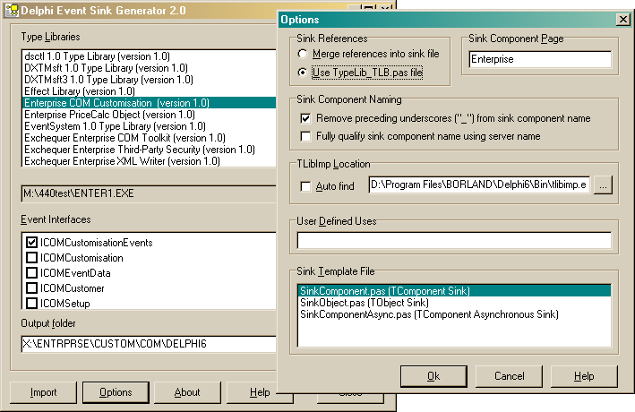

Delphi 6.01
1. As for Delphi 5

2. As for Delphi 5

3. Change the output folder to point to X:\ENTRPRSE\CUSTOM\COM\Delphi6.

4. As Delphi 5 except

TlibImp Location – Path | D:\Program Files\Borland\Delphi6\Bin\tlibimp.exe

5. As Delphi 5 except the files you are asked about overwriting will be in the x:\entrprse\custom\com\delphi6 directory.

6. As for Delphi 5

Delphi 5 [Not Supported from Exchequer v6.00]
1. Run the Event Sink and select ‘Enterprise COM Customisation’ in the Type Library list. Check that the path below the list points to the correct compiled .EXE (ENTER1/ENTERMH).

2. Check that only ICOMCustomisationEvents is selected in the Sink Interfaces list.

3. Change the output folder to point to X:\ENTRPRSE\CUSTOM\COM\Delphi5.

4. Go into Options and check the settings, the options should be:-

Sink References | Use Typelib_TLB.Pas file
Sink Component Page | Enterprise
Sink Component Naming | Remove preceeding undercores…
TlibImp Location - Auto Find | Off
TlibImp Location – Path | D:\Program Files\Borland\Bin\tlibimp.exe
User Defined Uses
Sink Template File | SinkComponent.Pas

5. Click the Import button, you will be asked if you want to overwrite Enterprise_TLB.Pas and EnterpriseEvents.Pas in x:\entrprse\custom\com\delphi5, this is normal, say Yes.

6. After the process has completed you need to edit the generated EnterpriseEvents.Pas in x:\entrprse\custom\com\delphi5 and remove the Register procedure, if this is not removed the Event Sink Component will be available to developers in the component palette.

Delphi 4 [Not Generated Unless Requested]
1. As for Delphi 5

2. As for Delphi 5

3. Change the output folder to point to X:\ENTRPRSE\CUSTOM\COM\Delphi4.

4. As Delphi 5 except

TlibImp Location - Path | D:\Program Files\Borland\Delphi4\Bin\tlibimp.exe

5. As Delphi 5 except the files you are asked about overwriting will be in x:\entrprse\custom\com\delphi5.

6. As for Delphi 5

Delphi 3 [Not Generated Unless Requested]
NOTE: The code generated for Delphi 3 by the Binh Ly Event Sink doesn’t compile!

Copy the following files from x:\entrprse\custom\com\delphi4 to x:\entrprse\custom\com\delphi3.:-

Enterprise_TLB.Dcr
Enterprise_TLB.Pas
EnterpriseEvents.Pas

Delphi 3 can apparently use the Delphi 4 code without changes

Rebuilding the Delphi Component Packages
As the interfaces have changed the Components should be rebuilt as a precaution.

Delphi 5
Follow these steps to rebuild the Delphi 5.0 Customisation Component Package, EntComD5:-

1) Load the project x:\entrprse\custom\com\delphi5\EntComD5.Dpk and recompile it.

Delphi 4
Follow these steps to rebuild the Delphi 4.0 Customisation Component Package, EntComD4:-

1) Load the project x:\entrprse\custom\com\delphi4\EntComD4.Dpk and recompile it.

Delphi 3
Follow these steps to rebuild the Delphi 3.0 Customisation Component Package, EntComD3:-

1) In Component | Install Packages untick ‘Enterprise Delphi 3.0 COM Customisation’ , whilst this is ticked Delphi 3.0 keeps the package loaded, preventing it being rebuilt.

2) Load the project x:\entrprse\custom\com\delphi3\EntComD3.Dpk and rebuild it.

